Lab 8 Exercise
- Seach and filter endpoints
  - Search
Update CustomerRepository.java:
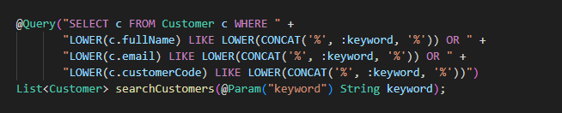

Test api
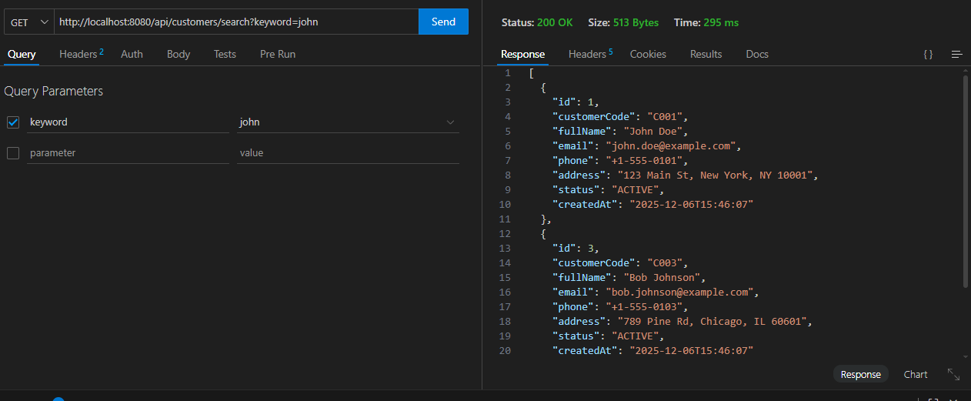

Work flow:
- Send request with method GET in header (search keyword as query parameter, no content in body request)
- Controller takes request
- Maps the URL with suitable search action
- Calls to service layer
- Service layer performs business logic (validates search keyword)
- Service layer calls Repository layer
- Repository executes LIKE query to search customer names and returns data table to service layer
- Service layer calls to DTO to format the response
- Return the formatted response to controller
- Controller responds data as object file (JSON file) with mapped attributes

  - Filter
Repository:
Service:
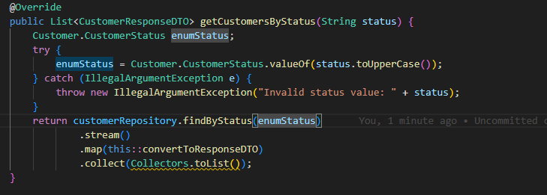
Controller:

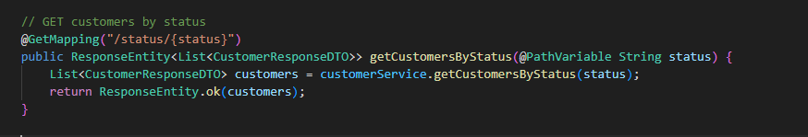

Test filter:
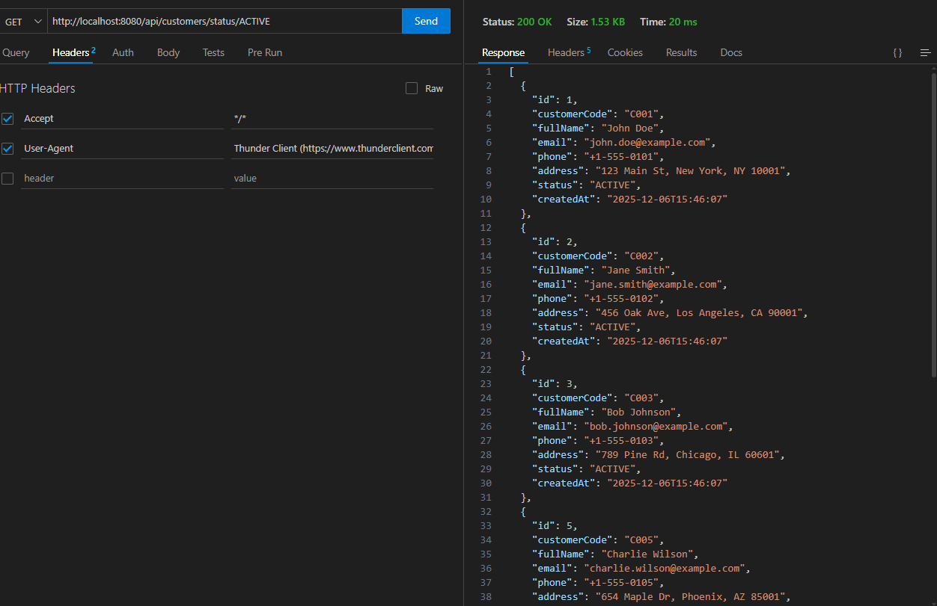

Work flow :
- Send request with method GET in header (filter criteria as query parameters, no content in body request)
- Controller takes request
- Maps the URL with suitable filter action
- Calls to service layer
- Service layer performs business logic (processes filter criteria)
- Service layer calls Repository layer
- Repository executes WHERE clause query with filter conditions and returns filtered data table to service layer
- Service layer calls to DTO to format the response
- Return the formatted response to controller
- Controller responds data as object file (JSON file) with mapped attributes

  - Multi-criteria search
Repository :
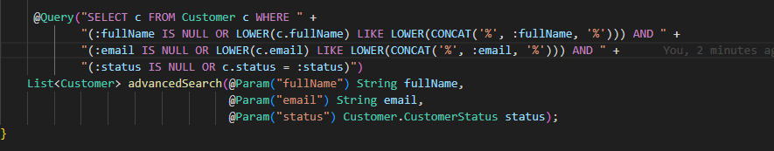
service:
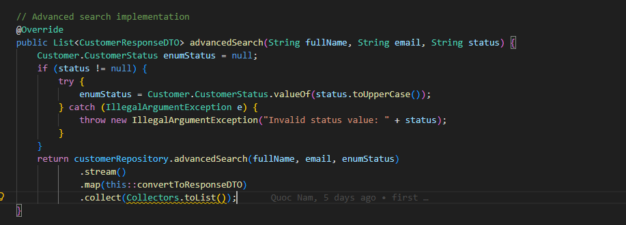
Controller :
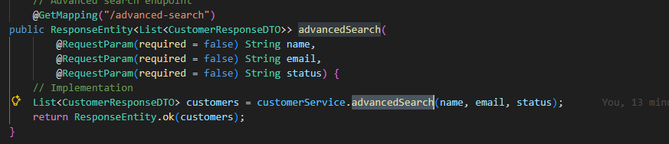
Test api:
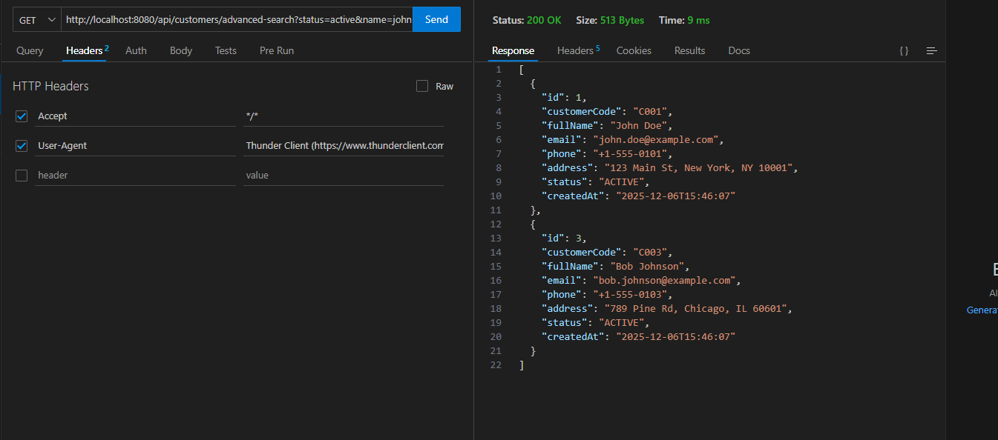

Work flow:
- Send request with method GET in header (multiple search parameters as query parameters, no content in body request)
- Controller takes request
- Maps the URL with suitable multi-criteria search action
- Calls to service layer
- Service layer performs business logic (combines multiple search criteria)
- Service layer calls Repository layer
- Repository executes complex query with multiple WHERE and LIKE conditions, returns matching data table to service layer
- Service layer calls to DTO to format the response
- Return the formatted response to controller
- Controller responds data as object file (JSON file) with mapped attributes

- Pagination and sorting
  - Pagination

Service:
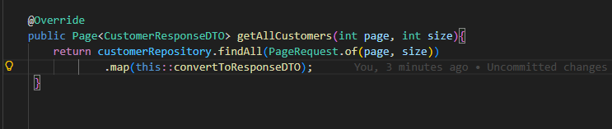
Controller:
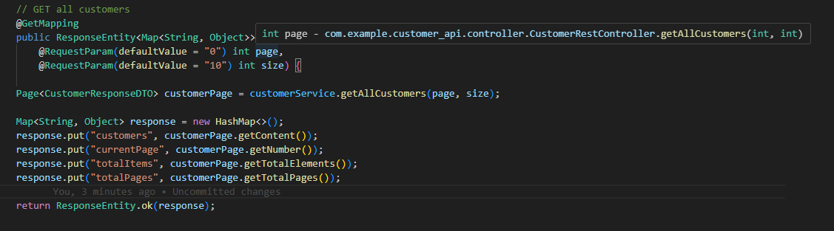
Test api:
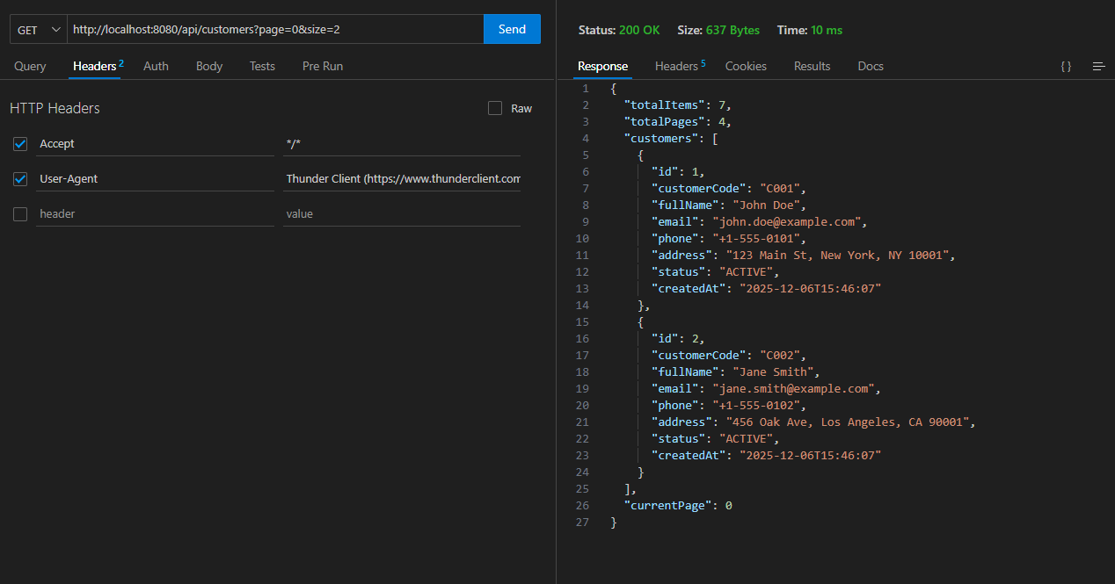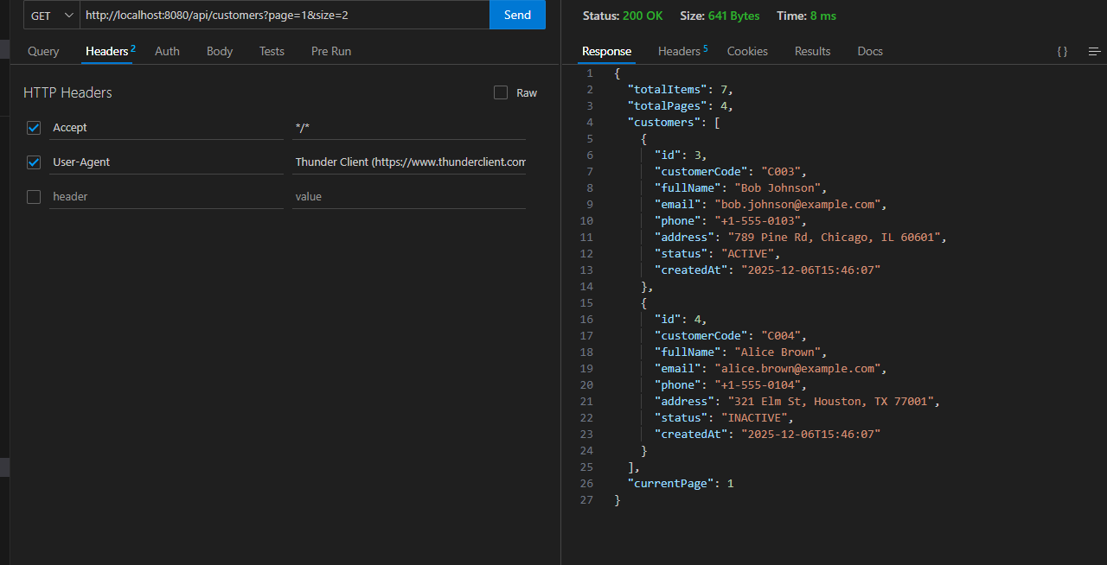

Work flow:
- Send request with method GET in header (page number and page size as query parameters, no content in body request)
- Controller takes request
- Maps the URL with suitable pagination action
- Calls to service layer
- Service layer performs business logic (calculates offset and limit based on page parameters)
- Service layer calls Repository layer with Pageable object
- Repository executes query with LIMIT and OFFSET clauses, returns paginated data table to service layer
- Service layer calls to DTO to format the response (includes page metadata: total pages, total elements, current page)
- Return the formatted response to controller
- Controller responds data as object file (JSON file) with mapped attributes and pagination metadata

  - Sorting
Service:
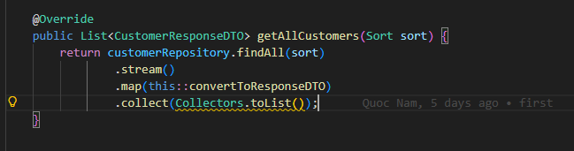
Controller:
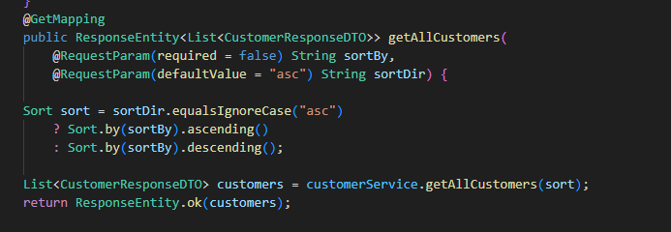
Test API:
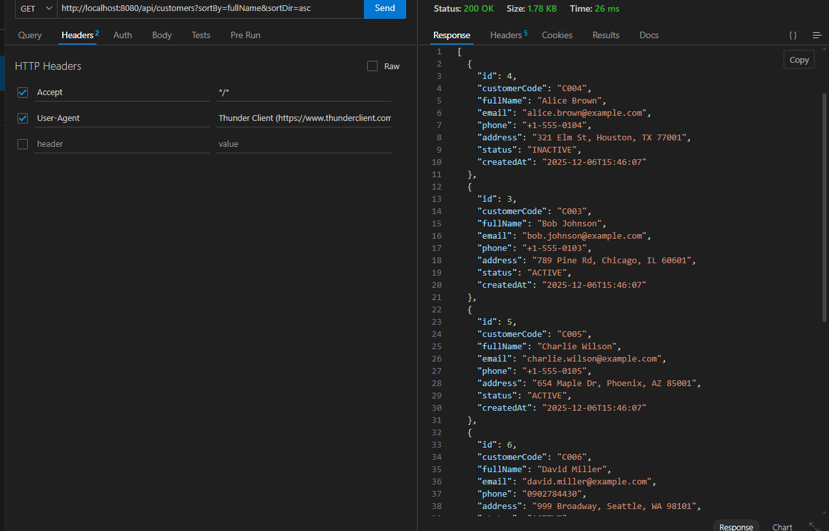

Work flow:
- Send request with method GET in header (sort field and direction as query parameters, no content in body request)
- Controller takes request
- Maps the URL with suitable sorting action
- Calls to service layer
- Service layer performs business logic (validates sort field and direction)
- Service layer calls Repository layer with Sort object
- Repository executes query with ORDER BY clause, returns sorted data table to service layer
- Service layer calls to DTO to format the response
- Return the formatted response to controller
- Controller responds data as object file (JSON file) with mapped attributes in sorted order

  - Combine pagination and sorting
Service:
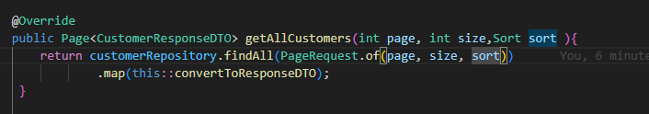
Controller:
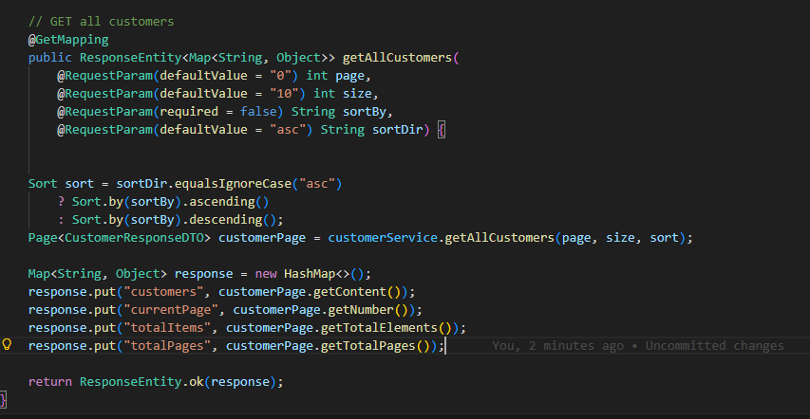
Test api:
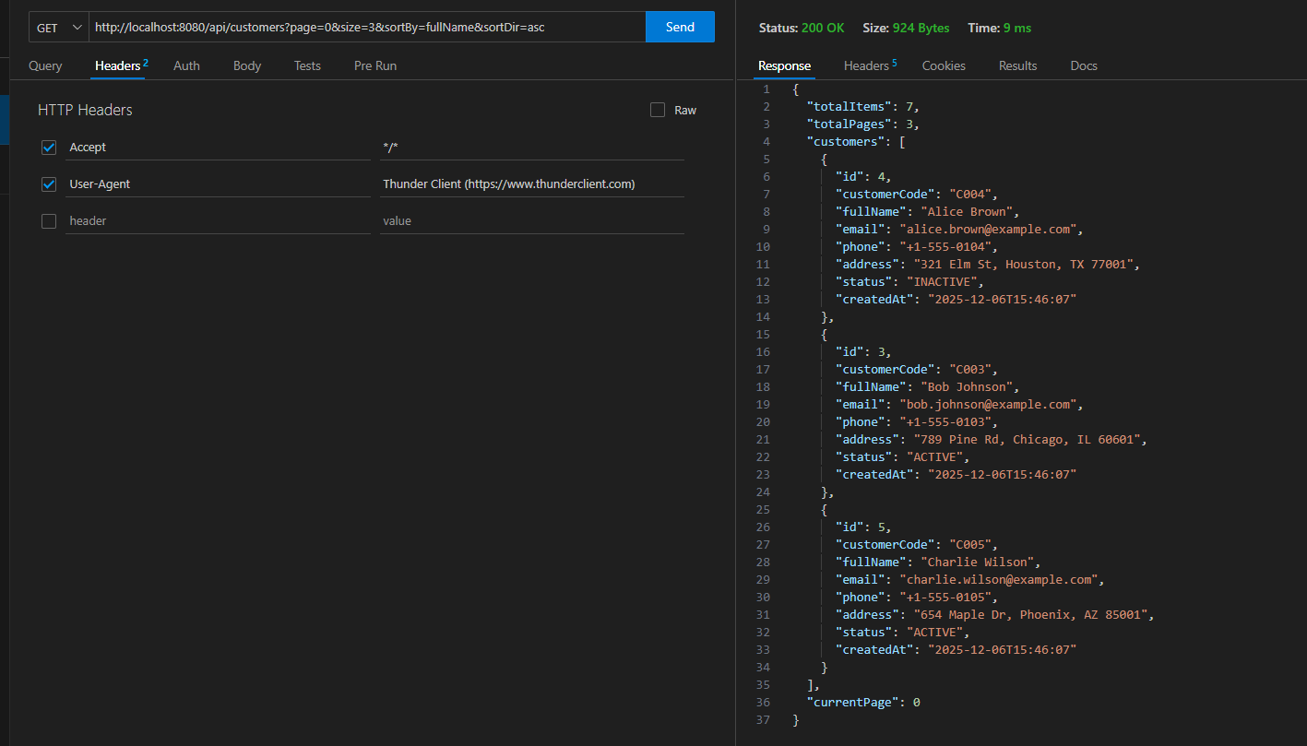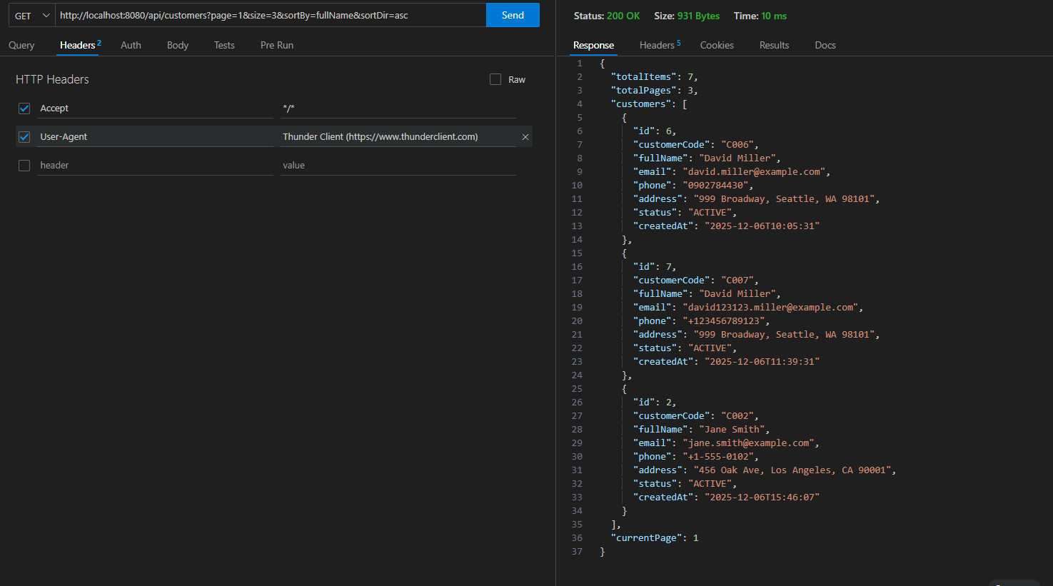

Work flow:
- Send request with method GET in header (page number, page size, sort field, and sort direction as query parameters, no content in body request)
- Controller takes request
- Maps the URL with suitable pagination and sorting action
- Calls to service layer
- Service layer performs business logic (combines pagination and sorting parameters into Pageable object)
- Service layer calls Repository layer with Pageable object containing both pagination and sorting information
- Repository executes query with ORDER BY, LIMIT, and OFFSET clauses, returns paginated and sorted data table to service layer
- Service layer calls to DTO to format the response (includes both sorted data and pagination metadata)
- Return the formatted response to controller
- Controller responds data as object file (JSON file) with mapped attributes in sorted order and pagination metadata
- Partial update with patch
  - Create update DTO
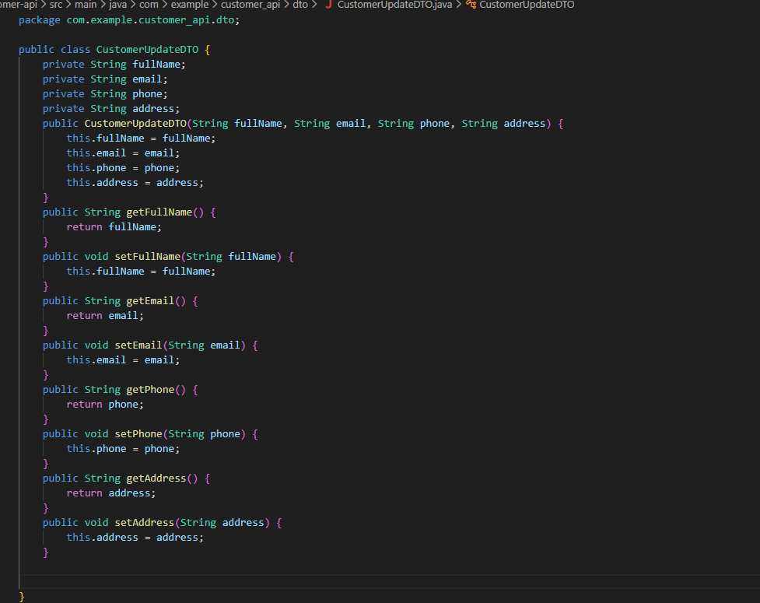
  - Implement Patch endpoints
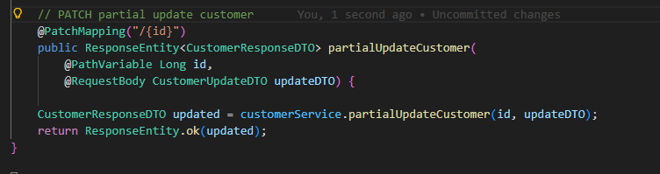
  - Add to Service

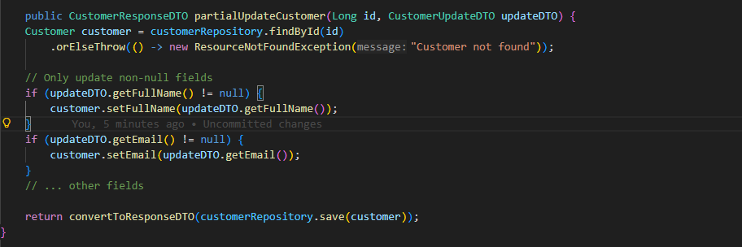
  - Test Patch vs Put
PUT:
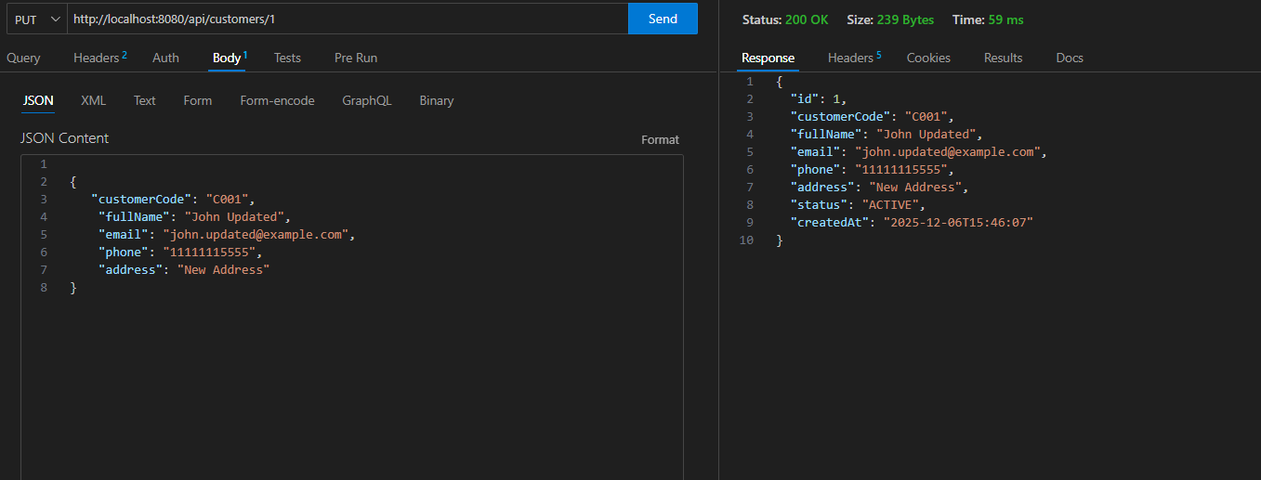
Patch:
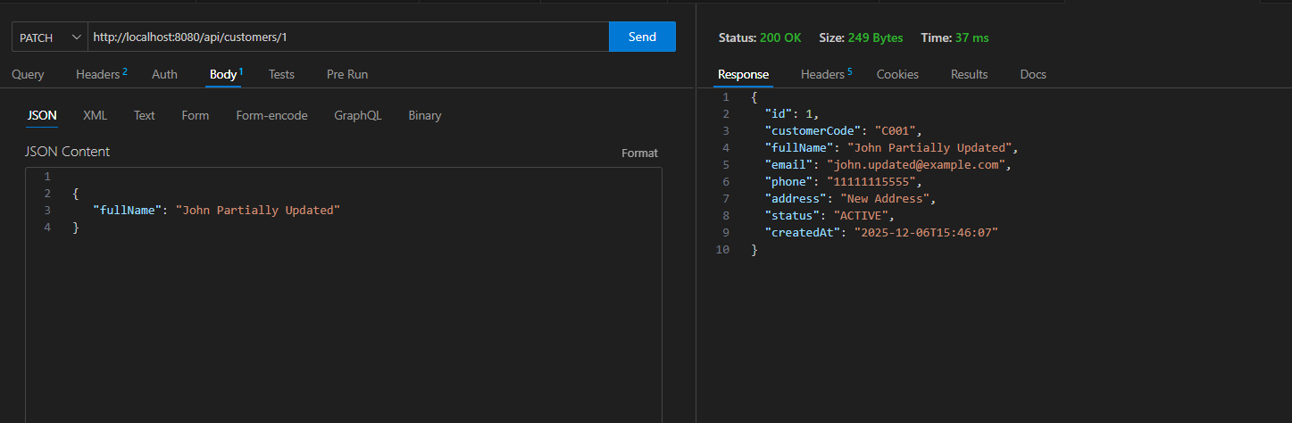

Patch work flow:
- Send request with method PATCH in header (partial customer data in JSON format in body request)
- Controller takes request
- Maps the URL with suitable patch action
- Calls to service layer
- Service layer performs business logic (updates only provided fields, preserves existing values for unprovided fields)
- Service layer calls Repository layer
- Repository executes UPDATE query with only modified fields, returns updated data table to service layer
- Service layer calls to DTO to format the response
- Return the formatted response to controller
- Controller responds data as object file (JSON file) with mapped attributes
- API documentation

